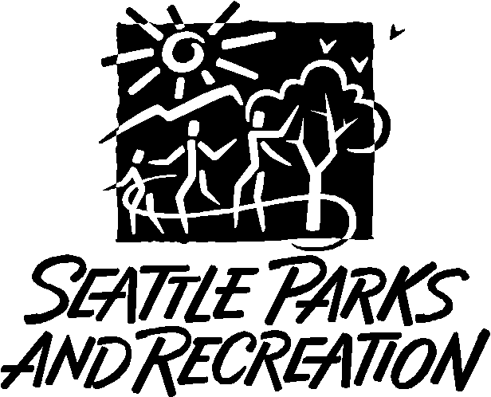**Seattle Parks and Recreation**

**Pesticide Application Record**

**Instructions:** Please complete one block per application date *and* location. Type or print legibly in gray boxes.Under *Total Quantity Applied* record the total volume of mixture applied in gallons for mixture applications, record total quantity applied in fluid ounces for straight product applications, or record number of shells used for EZ-Ject lance applications.

**EXAMPLE FORM**

|  |  |
| --- | --- |
| Name of Person for Whom Pesticide was Applied: | Seattle Parks/GSP Michael Helms |
| Address of Person for Whom Pesticide was Applied: | 1600 South Dakota St Seattle WA 98108 |
| Applicator’s Name: | Bridget Kelsh |
| Applicator’s Address: | 1600 South Dakota St Seattle WA 98108 |
| Applicator’s Washington State License Number: | 84641 |
| Miscellaneous Information: | SPR Natural Area Crew |

|  |  |  |  |  |  |  |
| --- | --- | --- | --- | --- | --- | --- |
| Date | Start Time | Stop Time | Park Name | Wind Direction | Wind Speed | Temperature |
| 5/25/24 | 9 am | 10:00 pm | Discovery Park | N | 5 mph | 65 |

**Spray Mix Example:**

|  |  |  |  |  |  |  |
| --- | --- | --- | --- | --- | --- | --- |
| Species | Method | | Equipment | | Application Area | Landscape type |
| Poison Hemlock | ☐ cut/treat  X foliar | ☐ injection | X backpack sprayer  ☐ injection gun | ☐ lance  ☐ small bottle | ☐ spot  X sq. ft.: 400  ☐ acres: | ☐ Forest  X Grassland  ☐ Wetland |

|  |  |  |  |  |  |
| --- | --- | --- | --- | --- | --- |
| Full Product Name | EPA Registration Number | Mix or Straight Product? (all are Mix) | Mix Rate  (in fluid oz./gallon OR  .008 fl. oz/shell for EZ Ject) | Percent Concentration  of Each Product (%) | Total Quantity Applied  IN GALLONS OR # OF SHELLS; (Fluid oz divided by 128 = gal.) |
| Garlon 4 Ultra | 62719-40 | Mix | 2.56 oz./gal | 2% | 1 gallon |
| Competitor | 2935-04001 | Mix | 1.28 oz./gal | 1% |  |
|  |  |  |  |  |  |
|  |  |  |  |  |  |

|  |  |  |  |  |  |  |
| --- | --- | --- | --- | --- | --- | --- |
|  |  |  |  |  |  |  |
| Date | Start Time | Stop Time | Park Name | Wind Direction | Wind Speed | Temperature |
| 5/28/16 | 10:30 am | 2:30 pm | Discovery Park | N | 5 mph | 65 |

**EZ-Ject Example:**

|  |  |  |  |  |  |  |
| --- | --- | --- | --- | --- | --- | --- |
| Species | Method | | Equipment | | Application Area | Landscape type |
| Holly, Laurel, English Hawthorne | ☐ cut/treat  ☐ foliar | X injection | ☐ backpack sprayer  ☐ injection gun | X lance  ☐ small bottle | ☐ spot  ☐ sq. ft.:  X acres: 2.5 | X Forest  ☐ Grassland  ☐ Wetland |

|  |  |  |  |  |  |
| --- | --- | --- | --- | --- | --- |
| Full Product Name | EPA Registration Number | Mix or Straight Product? (all are Mix) | Mix Rate  (in fluid oz./gallon OR  .008 fl. oz/shell for EZ Ject) | Percent Concentration  of Each Product (%) | Total Quantity Applied  IN GALLONS OR # OF SHELLS; (Fluid oz divided by 128 = gal.) |
| EZject Copperhead | 83220-2 | Mix | .008 fl oz/ shell | N/A | 168 shells  (0.008 oz/shell x 168 shells = 1.344 fl oz) |

|  |  |  |  |  |  |  |
| --- | --- | --- | --- | --- | --- | --- |
|  |  |  |  |  |  |  |
|  |  |  |  |  |  |  |
| Date | Start Time | Stop Time | Park Name | Wind Direction | Wind Speed | Temperature |
| 5/25/24 | 9 am | 10:00 pm | Discovery Park | N | 5 mph | 65 |

**Cut/treat 100% Example:**

|  |  |  |  |  |  |  |
| --- | --- | --- | --- | --- | --- | --- |
| Species | Method | | Equipment | | Application Area | Landscape type |
| Blackberry, Holly | X cut/treat  ☐ foliar | ☐ injection | ☐ backpack sprayer  ☐ injection gun | ☐ lance  X small bottle | X spot  ☐ sq. ft.:  ☐ acres: | ☐ Forest  X Grassland  ☐ Wetland |

|  |  |  |  |  |  |
| --- | --- | --- | --- | --- | --- |
| Full Product Name | EPA Registration Number | Mix or Straight Product? (all are Mix) | Mix Rate  (in fluid oz./gallon OR  .008 fl. oz/shell for EZ Ject) | Percent Concentration  of Each Product (%) | Total Quantity Applied  IN GALLONS OR # OF SHELLS; (Fluid oz divided by 128 = gal.) |
| Garlon 4 Ultra | 524-517 | Mix | 128 fl oz/ gallon | 100% | (8 fl. Oz divided by 128 = .0625)  .0625 gallons |
|  |  |  |  |  |  |
|  |  |  |  |  |  |

|  |  |  |  |  |  |  |
| --- | --- | --- | --- | --- | --- | --- |
| Date | Start Time | Stop Time | Park Name | Wind Direction | Wind Speed | Temperature |
| 5/25/24 | 9 am | 10:00 pm | Discovery Park | N | 5 mph | 65 |

**Cut/Treat Dilute Example:**

|  |  |  |  |  |  |  |
| --- | --- | --- | --- | --- | --- | --- |
| Species | Method | | Equipment | | Application Area | Landscape type |
| Blackberry, Holly | X cut/treat  ☐ foliar | ☐ injection | ☐ backpack sprayer  ☐ injection gun | ☐ lance  X small bottle | X spot  ☐ sq. ft.:  ☐ acres: | ☐ Forest  X Grassland  ☐ Wetland |

|  |  |  |  |  |  |
| --- | --- | --- | --- | --- | --- |
| Full Product Name | EPA Registration Number | Mix or Straight Product? (all are Mix) | Mix Rate  (in fluid oz./gallon OR  .008 fl. oz/shell for EZ Ject) | Percent Concentration  of Each Product (%) | Total Quantity Applied  IN GALLONS OR # OF SHELLS; (Fluid oz divided by 128 = gal.) |
| Garlon 4 Ultra | 524-517 | Mix | 64 fl oz/ gallon | 50% | (4 fl. Oz divided by 128 = .03125)  .03125 Gallons |
|  |  |  | **42.67 fl oz/gallon** | **33%** |  |
|  |  |  | **32 fl oz/gallon** | **25%** |  |