Acer circinatum, Vine maple

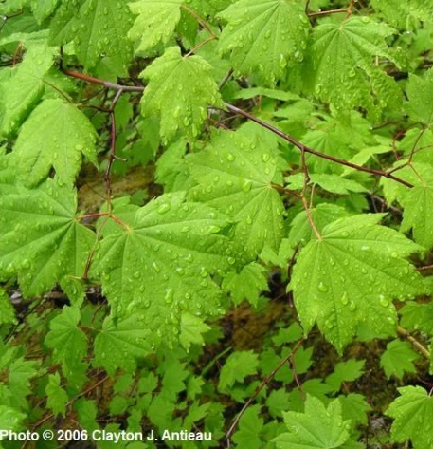
Height / Form | 1 to 8 meters tall; tree, shrub
Flowers | Flowers March, April, May, June. Flowers few, perfect or imperfect, 6-9 mm. broad, terminal on short, lateral shoots; sepals 4-5, purplish; petals 4-5, white, distinct, shorter than the sepals; stamens 8, inserted on the inner edge of a fleshy disk, those of the staminate flowers longer than the sepals, those of the perfect flowers much shorter; styles and stigmas 2; ovary superior, 2-celled
Fruits | Samara, the wings widely spreading.
Leaves | Leaves opposite, nearly rotund, cordate-based, palmately 7- to 9-lobed, serrate, 3-6 cm. long and broad, with soft hairs on the lower surface and hairy veins above.
Distribution | West of Cascades crest in WA, AK to northern CA
Habitat | Wetland, riparian, rocky/gravelly, forest, disturbed
Sun and Soils | Partial shade/sun, mostly shady, full shade; well-drained soils, nutrient rich soils

Frangula purshiana ssp. Purshiana, Cascara, Buckthorn

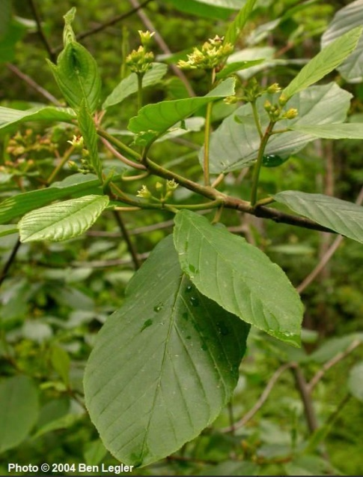
Height / Form | Deciduous shrub or small tree up to 10 m. tall
Flowers | Flowers March, April, May, June; Flowers in umbels on axillary peduncles, perfect or imperfect (if imperfect, the plant monoecious); calyx bell-shaped, 5-lobed, 3-4 mm. long, greenish, lined with a thin disk to which the petals and stamens are attached; petals 5, small, hooded; stamens 5, nearly sessile; ovary superior, free of the disk.
Leaves | Leaves alternate, with stout petioles 5-20 mm. long, the blades oblong-ovate to oblong-obovate, 6-13 cm. long, very finely serrulate, with 10-12 prominent, lateral veins on each side.
Distribution | Occurring on both sides of the Cascades crest in Washington; British Columbia to California, east to Idaho and Montana.
Habitat | Forest understory and margins from low to moderate elevations in the mountains.

Salix sp., Willow species

Species | Salix lasiandra  Pacific willow | Salix scouleriana  Scouler’s willow | Salix hookeriana  Hooker’s willow
Photo | 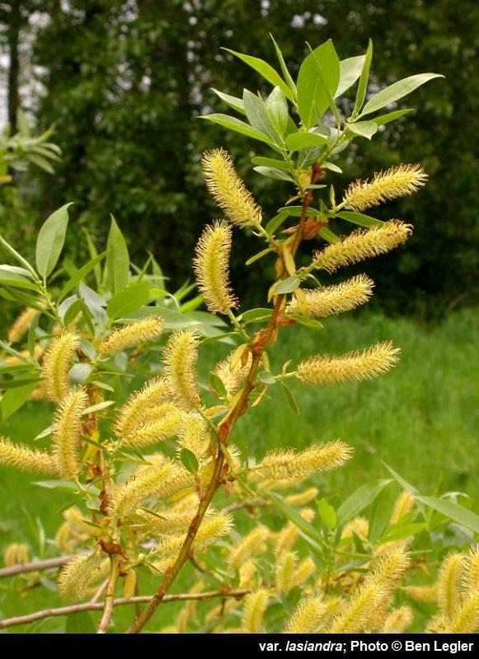 | 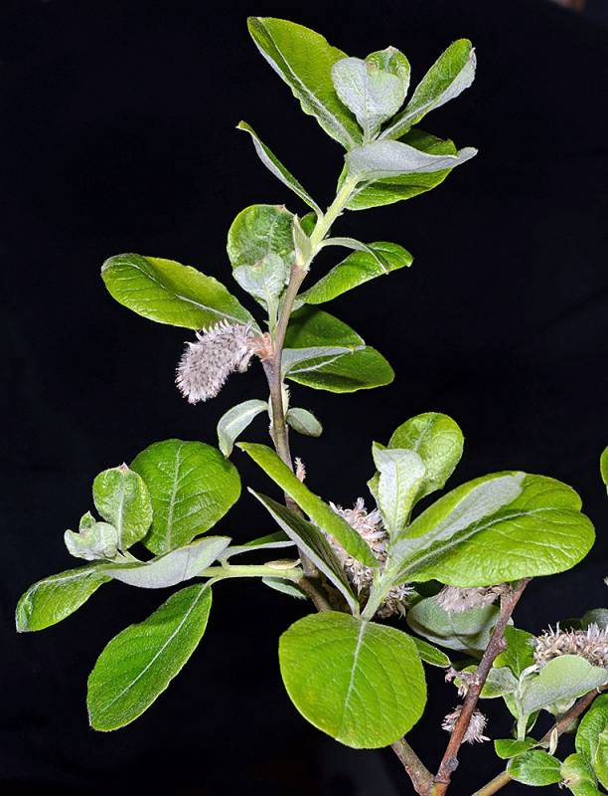 | 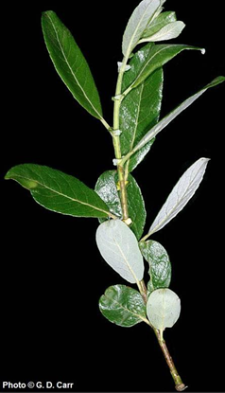
Height / Form | 15 to 45 feet (3 to 14 m) in height, largest native willow | Small multi-stemmed tree or shrub, growing 6-36 feet (2-12m). | 2 to 26 feet in height
Flowers | This plant produces drooping catkins. Males catkins are green to yellow, females catkins are green or pale yellow. | March-June | produces unisex flowers on catkins. The catkins are stout in shape and unstalked. The flowers do not contain sepals or petals and are yellowish-green in color. The floral bracts are dark in color and contain straight or wavy hairs.
Fruits | Capsules which split open to release the seeds. Each seed is surrounded by a tuft of hairs and grows on stalks which are diminutive (0.8 to 4 mm) in length. Once fruits develop, seeds are dispersed in the wind. |  | Capsules which split open to release the seeds. Each seed is surrounded by a tuft of hairs. The capsules grow on very short stalks.
Leaves | Alternate leaves are produced which are leathery and waxy dark green upper surface, with a lighter green, hairless underside. Leaf shapes are generally narrow and lanceolate with a pointed tip and a finely serrated margin | leaves are smaller than some of the other willows, only 1-3 inches (3-8cm), rounded or pointed at the tip, widest above the middle, tapering to a narrow base. | Alternate arrangement. The leaves are simple and elliptic to lance-shaped, or broadly egg-shaped. The lower surface of the leaves are glaucous, contain long soft-hairy or short-woolly to shaggy hairs, or are sometimes smooth. The margins are entire or toothed with bases and tips which are pointed to rounded. Leaves are 1-1/2 to 4-1/3 inches in length and 1 to 1-1/4 inches in width.
Distribution | This plant grows from Alaska to California (including British Columbia), and east to Manitoba and New Mexico. This plant grows on both sides of the Cascades crest, and at the coast in Washington. | Widely distributed on both sides of the Cascades crest in Washington; Alaska to California, east to the Rocky Mountains and northern Great Plains | From British Columbia to California. In Washington, this plant grows on both sides of the Cascades crest and at the coast
Habitat | Forest understory and margins from low to moderate elevations in the mountains. | Moist woods and streambanks, lowlands to moderate elevations in the mountains. Scouler’s Willow is also known as Upland Willow, due to its ability to thrive in drier habitats.

Ribes lacustre, Black Gooseberry, Swamp Currant, Swamp Gooseberry, Swamp Black Gooseberry

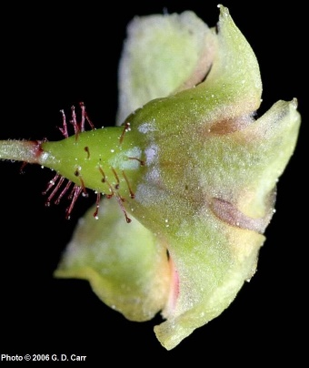
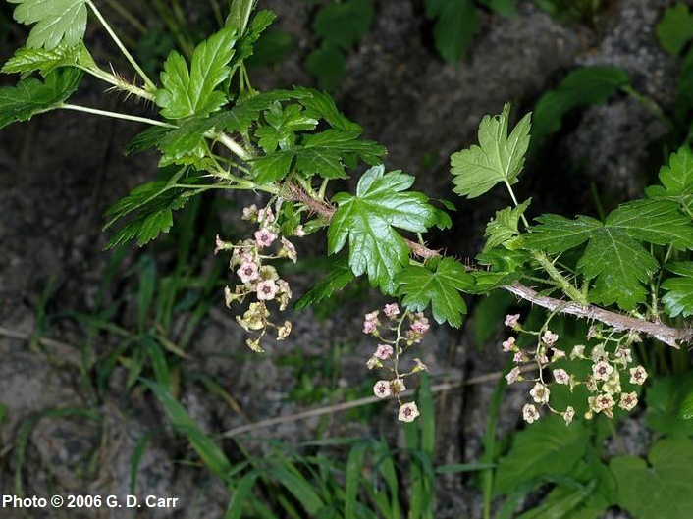
Height / Form | 3 to 5 feet, shrub
Flowers | small, saucer-shaped flowers, reddish to maroon in color, are produced in drooping clusters of 7 to 15. The ovary is glandular-hairy
Leaves | ternate leaves are produced, with 5 deeply-indented lobes and a heart-shaped base. The margins are toothed, and the leaves are not glandular or hairy. The shape of the leaf is similar to a maple leaf. The leaves are dark glossy green in color and grow approximately 1/2 of an inch to 1 inch (1 to 5 cm) in width.
Fruits | Fruits are dark purple in color, bristly with stalked glands, spherical in shape and grow 1/4 of an inch to 3/8 of an inch (6 to 8 mm) in length
Distribution | From Alaska to California on both sides of the Cascades crest and at the coast in Washington.
Habitat | moist forests, along stream banks and forested slopes and ridges

Scirpus microcarpus. panicled bulrush, small fruited bulrush

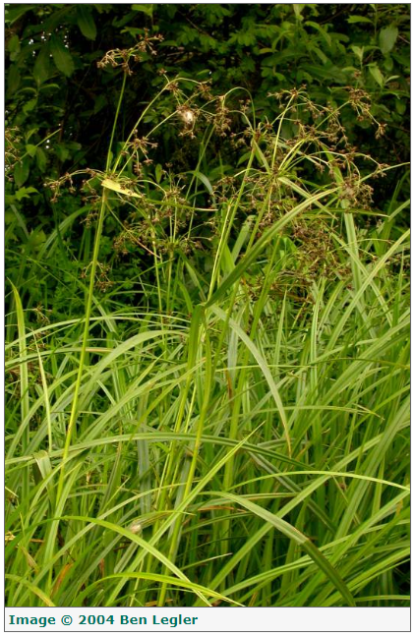
Height / Form | Coarse, herbaceous perennials from stout, creeping rhizomes, the stems arising singly or a few together, 6-15 dm. tall, obscurely three-sided.
Flowers | Inflorescence a compound, terminal cyme, with very numerous spikelets 4-6 mm. long, sessile in small clusters on peduncles; inflorescence subtended by several unequal, leaf-like, sheathless bracts.
Leaves | Stems leafy, the leaf blades flat, grass-like, 8-15 mm. wide and up to several dm. long, the sheaths tinted with reddish-purple.
Fruits | Achenes lenticular, pale, 1.0-1.2 mm. long.
Distribution | Widely distributed on both sides of the Cascades crest in Washington
Habitat | Wet ground, ditches, shorelines, streambanks, and other riparian areas from low to moderate elevations in the mountains

Athyrium filix-femina ssp. Cyclosorum, lady fern, common lady-fern

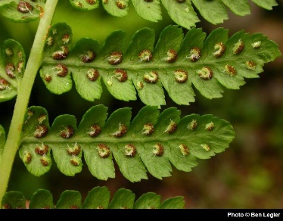
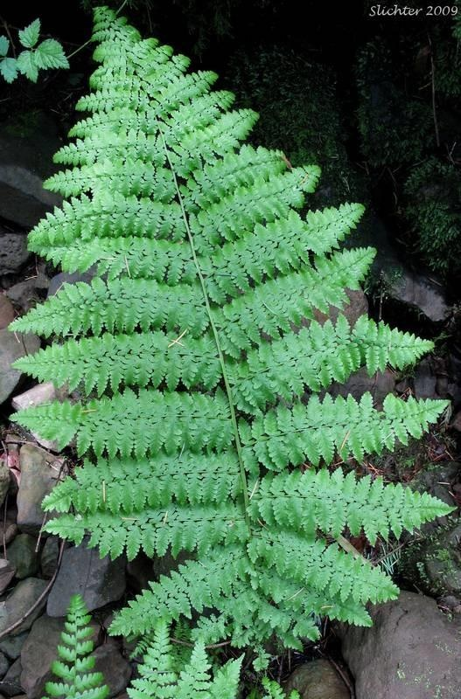
Height / Form | 12 to 71 inches (30 to 180 cm) in height
Leaves | The stipes are short, fragile, and scaly at the base. The blades are longer than the stipes, narrowly to broadly lance-shaped and taper at both ends (diamond-shaped profile). The blades are 2 to 3 times pinnate, and grow in numerous vase-like tufts 4 to 28 inches (10 to 70 cm) in width. The leaflets contain 20 to 40 pairs with the upper and lower pairs progressively reduced. The ultimate segments are toothed or lobed.
Sori | Elongated and curved sori are produced in oblong to horseshoe shapes. The indusium is also elongated and curved, and attached to one side with hairs and teeth which shrivel early in the season.
Distribution | Occurring on both sides of the Cascades crest in Washington; Alaska to California, east to the northern Great Plains.
Habitat | Moist woods, meadows, forest edge, and shaded riparian corridors from low to middle elevations.

Oenanthe sarmentosa, water parsley

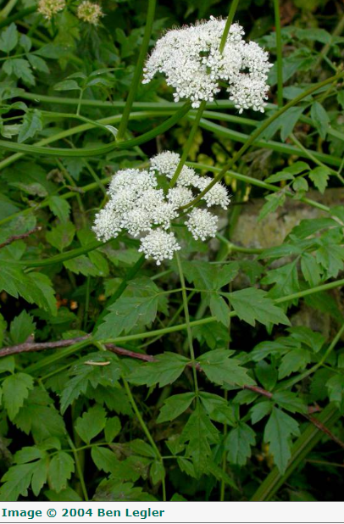
Height / Form | Glabrous, weak, freely-branched perennial from fibrous roots, generally reclining and rooting at the nodes, the stem up to 1 m. long.
Leaves | Leaves mostly bipinnate, the toothed to cleft leaflets 1.5-6 cm. long and 7-50 mm. wide, the primary lateral veins of the leaflets directed to the marginal teeth.
Flowers | Inflorescence a compound umbel, the peduncles attached opposite the leaves; rays 10-20, 1.5-3 cm. long; involucre of a few narrow bracts or wanting; involucel of evident, narrow bractlets; calyx teeth evident, persistent; flowers white, the styles elongate.
Distribution | occurring chiefly west of the Cascades crest in Washington; Alaska to California
Habitat | Low elevation wet areas, often in standing water.

Symphyotrichum subspicatum, Douglas’ aster

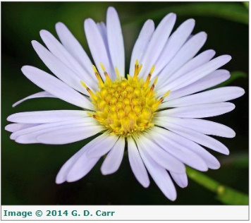
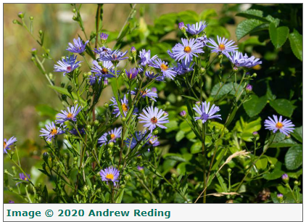
Height / Form | Fibrous-rooted perennial from a creeping rhizome, highly variable in size, the herbage pubescent.
Leaves | Leaves toothed, the lower oblanceolate, petiolate, often deciduous; other leaves lanceolate, sessile, 5-12 cm. long and 1-3 cm. wide, 4-8 times as long as wide
Flowers | Inflorescence an open, leafy panicle; involucre bracts firm, thick, strongly imbricate, the tips often recurved, the base conspicuously yellowish or brownish, the margins papery; disk flowers numerous, yellow; rays blue to purple, 1-2 cm. long; pappus of numerous reddish capillary bristles
Distribution | Occurring on both sides of the Cascades crest in Washington; British Columbia to California, east to Alberta, Montana and Idaho
Habitat | Moist woods, streambanks and seashores

Potentilla anserina, Pacific silverweed

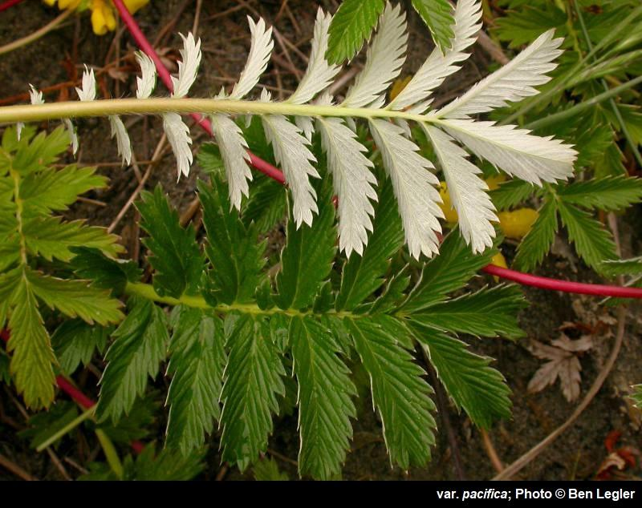
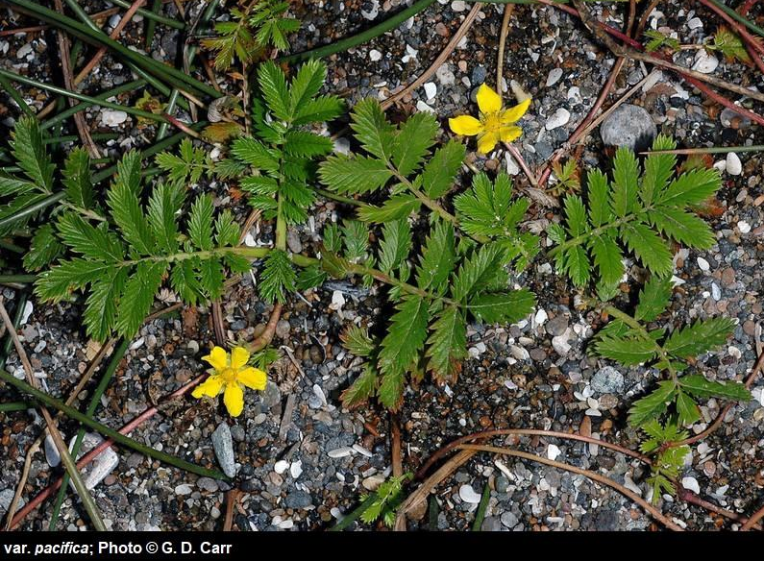
Height / Form | Herbaceous, grows up to 16 inches (40 cm) in height.
Leaves | Upright basal leaves grow up to 16 inches (40 cm) in length. The leaf blades can be greenish on the upper surface or whitish silky-woody on both surfaces. The leaflets are combination of large and small with 15 to 25 leaflets on each stem.
Flowers | Single yellow flower grow on leafless stalks up to 8 inches (20 cm) in height. The flowers are oval, contain 20 to 25 stamens and numerous pistils, and the petals grow approximately 1/2 of an inch (8 to 12 mm) in length.
Distribution | This plant grows from Alaska to California (including British Columbia) and east to the Rocky Mountains, Great Plains, Great Lakes region, and northeastern North America
Habitat | Wet, alkaline areas from coast to arid inlands

Lonicera ciliosa, orange honeysuckle, western trumpet honeysuckle

Height / Form | Vine, climbs up to 20 feet (6 m) in height
Leaves | Opposite leaves are produced. The leaves are hairless, except for a few marginal hairs, the lower surface is glaucous, and broadly elliptical in shape. The leaves are 1-5/8 inches to 4 inches (4 to 10 cm) in length and approximately 3/4 of an inch to 2 inches (2 to 5.5 cm) in width. The last pair of leaves on each twig merge to form a disk
Flowers | Reddish-orange to yellowish-orange flowers grow in dense, short, terminal inflorescences. The corolla is relatively 2-lipped with the tube 3 to 4 times the length of the lips and swollen on one side above the base. The corolla is 1 to 1-5/8 inches (2.5 to 4 cm) in length. The flower contains 5 hairless stamens and the inferior ovary contains 3 cells
Fruit | Clusters of orange-red, translucent berries are produced. The berries are up to 3/8 of an inch (1 cm) in diameter and contain several seeds.
Habitat | forests

